**Introduction**

The dataset provides observations of various sidewalk obstructions categorized into seven main issues: Parked Vehicles Obstructing Sidewalks, Narrow or Limited Sidewalk Space, Uneven or Hazardous Pavement, Obstacles from Natural Elements, Miscellaneous Obstructions, Blocked or Limited Crossing Access, and Debris and Environmental Hazards. The analysis below details the categories observed, their frequency, and overlapping issues.

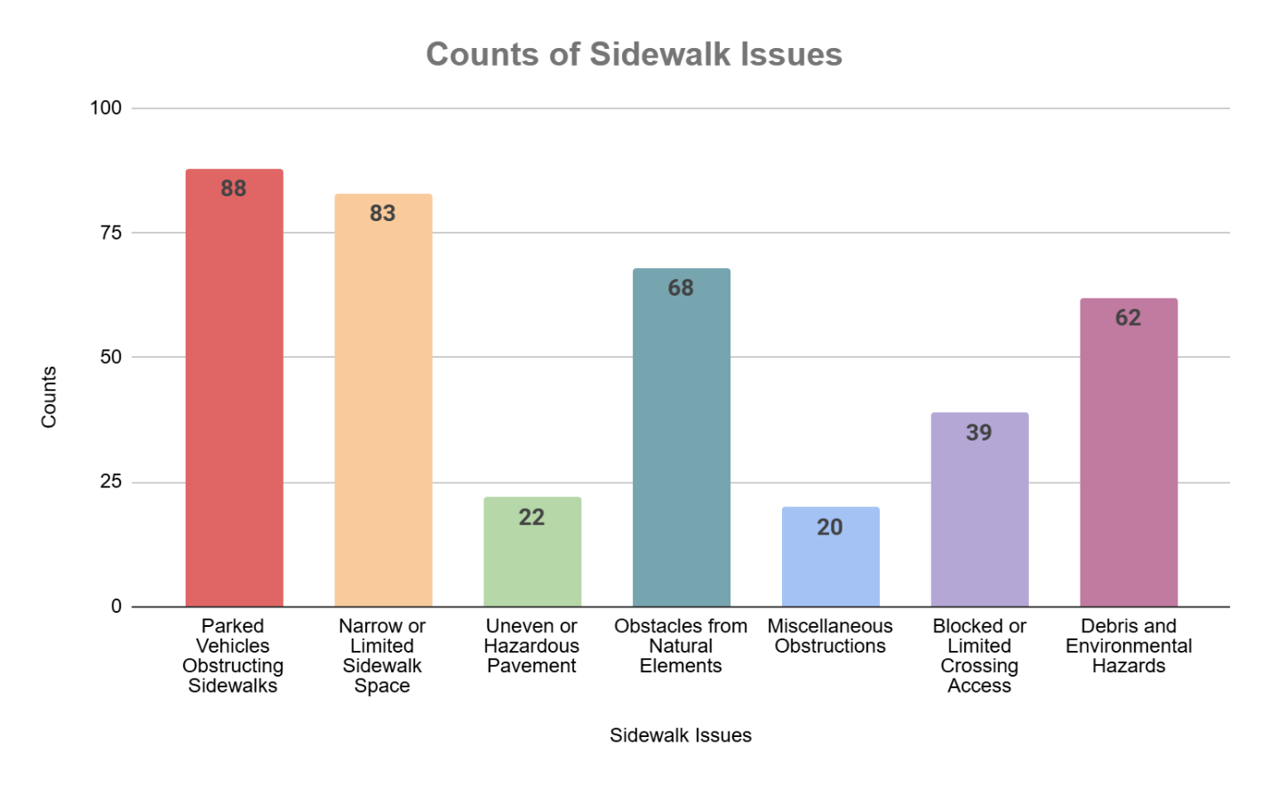

**Observations**

1. **Parked Vehicles Obstructing Sidewalks**  
   This issue is the most frequent in the dataset, with **88 instances** (23.04% of all issues). Cars, motorcycles, and scooters blocking pedestrian paths force pedestrians onto roads, creating significant safety concerns.
2. **Narrow or Limited Sidewalk Space**  
   This issue is also highly represented, with **83 instances** (21.73% of all issues). Sidewalks are often constrained by parked vehicles, natural elements like trees, or other permanent structures, leaving limited space for safe pedestrian movement.
3. **Uneven or Hazardous Pavement**  
   With **22 instances** (5.76% of all issues), this is one of the less common categories. Cracks, raised areas, and poorly maintained sidewalks create tripping hazards, especially for vulnerable pedestrians such as older adults or children.
4. **Obstacles from Natural Elements**  
   This category appears **68 times** (17.80% of all issues), including obstructions from overgrown plants, tree trunks, and fallen leaves. These natural barriers often coincide with debris and narrow sidewalks, exacerbating the problem.
5. **Miscellaneous Obstructions**  
   This is a relatively infrequent issue, with **20 instances** (5.24% of all issues). Examples include trash bins, tools, and construction materials temporarily blocking sidewalks, creating short-term but noticeable disruptions.
6. **Blocked or Limited Crossing Access**  
   There are **39 instances** (10.21% of all issues) where vehicles or objects block pedestrian crossings, reducing visibility and making crossings unsafe or inaccessible.
7. **Debris and Environmental Hazards**  
   With **62 instances** (16.23% of all issues), this is a significant problem. Observations include broken glass, litter, and graffiti. These hazards are often seen alongside other issues like parked vehicles or narrow sidewalks, adding to the difficulty of navigating sidewalks.

**Overlapping Problems**

Many issues occur together, such as:

* Parked vehicles frequently combined with narrow sidewalk space and debris.
* Natural obstacles often coinciding with debris and limited sidewalk space.
* Blocked crossings overlapping with natural obstacles and uneven pavement.

**Conclusion**

All seven categories are well-represented in the dataset, with **Parked Vehicles Obstructing Sidewalks** and **Narrow or Limited Sidewalk Space** being the most frequent. Many issues overlap, compounding challenges for pedestrians. The "Other" category was not needed, as all observations fit within the predefined categories.